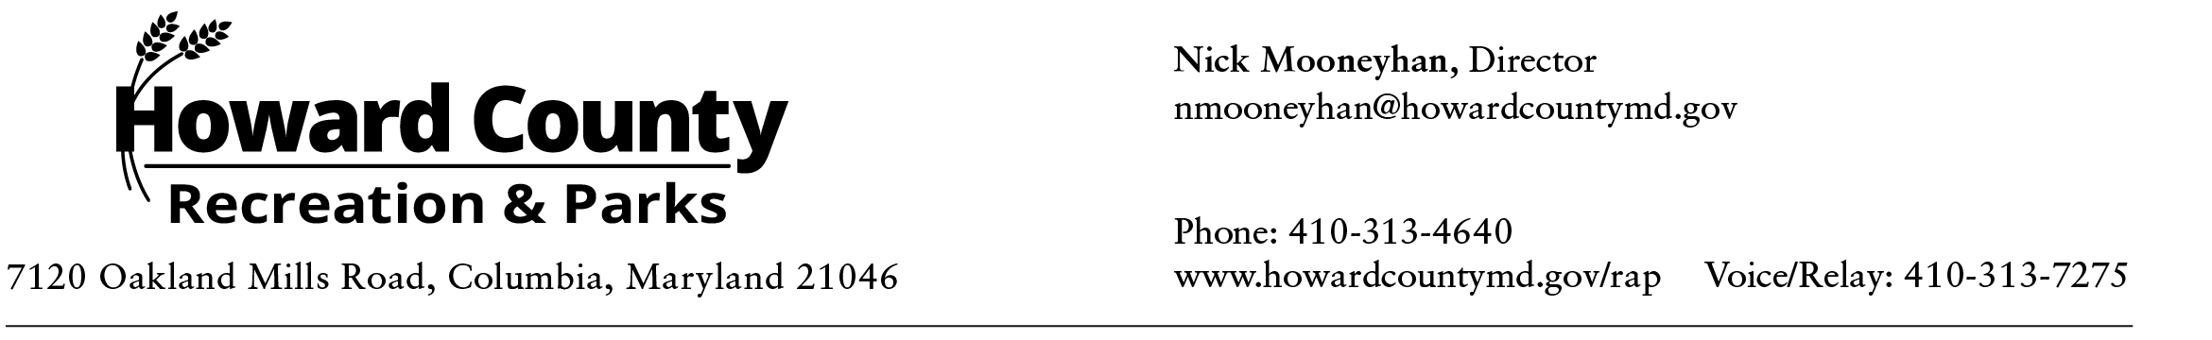

Historic and Historic Sites Advisory Workgroup Committee Meeting
AGENDA
Friday, January 30, 2026, 10:30am-12:00pm (VIRTUAL)

- Welcome
- Recommendation Examples
- Sub-Committee Chair Voting
- Sub-Committee Updates
- Knowledge Share/Field Trips
- February Sub-Committee
- Adjourn

Meeting link:
https://howardcountymd.webex.com/howardcountymd/j.php?MTID=m421f38a8e9c8efc4059b64c8d9bc6b7c
Meeting number:
2304 617 1339
Password: Advisory26
Host key: 414755
Join by video system
Dial 23046171339@howardcountymd.webex.com
You can also dial 173.243.2.68 and enter your meeting number.
Join by phone
1-650-479-3207 Call-in number (US/Canada)
Access code: 2304 617 1339
Host PIN: 3136


