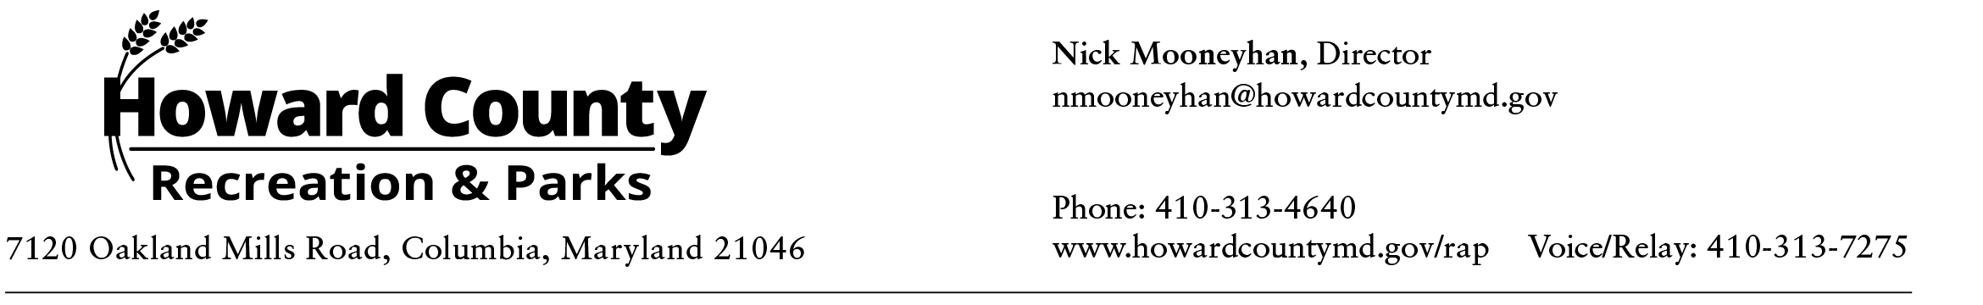

Historic and Historic Sites Advisory Workgroup Committee Meeting
AGENDA
Tuesday, September 30, 2025, 11am-12:30pm (VIRTUAL)

- Welcome
- Executive Order Reading
- Open Meeting Act
- Member Introductions
- Subcommittee Groups
- Adjourn

Meetings are open to the public. We offer a virtual option for the public to tune in if they cannot attend in person.

VIRTUAL LOG-IN FOR PANELISTS
Join link:
https://howardcountymd.webex.com/howardcountymd/j.php?MTID=mef35e8aee5b50d8fa949188becf7c5f4

Webinar number:
2313 750 6085

Panelist password:
preservation (77373782 when dialing from a phone or video system)

Join by video system
Dial 23137506085@howardcountymd.webex.com
You can also dial 173.243.2.68 and enter your meeting number.

Join by phone
1-650-479-3207 Call-in toll number (US/Canada)

Access code: 231 375 06085

