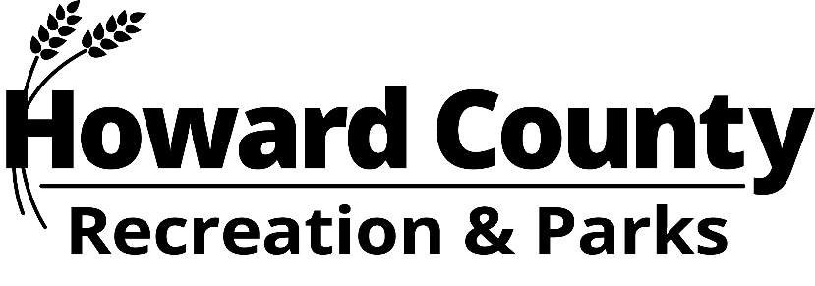

Public Garden Focus Group
Minutes August 21, 2024 6-8pm
DRP HQ, Conference Rm 1,
7120 Oakland Mills Rd
Columbia, MD 21046

MEMBERS PRESENT

Meg Boyd, Bonnie Bricker, Chiara D’Amore (virtual), Janssen Evelyn, Greg Garin, Peggy Hannon, Deeba Jafri, Richard Jones (Virtual - Vice Chair), Lisa Marini (virtual), Christine McComas, Liz O’Brien, Stephanie Oberle (Chair), and Gregg Petersen.

MEMBERS ABSENT
Jay Polaki and Lauren Turner.

STAFF PRESENT
Nick Mooneyhan, Director (Virtual)
Scott Munroe, Park Planner & Landscape Architect
Kimberly Pruim, Superintendent, Bureau of Administrative Services and Administrator to the Focus Group (Virtual)
Jason Liu, DTCS

CALL TO ORDER
Having taken attendance, Ms. Oberle called the meeting to order at 6:03pm. With 13 members present, quorum was established.

APPROVAL OF MINUTES
Minutes were shared electronically and made available in print for members attending in person. Bonnie Bricker made the motion to approve. Deeba Jafri seconded. Minutes approved unanimously.

OLD BUSINESS
None.

NEW BUSINESS AND MEMBER DISCUSSION
A chart was created comparing the work of each of the committees to evaluate overlaps and themes.

There was a brief discussion about the inclusion of public comment into the report and the importance of written testimony. Where the public had questions about inclusion of native vs. non-native plants, it was noted the work of the Public Garden Focus Group should evaluate and weave their recommendations into the report for the County and Administration to consider.

Scott Monroe provided a PowerPoint presentation of the Longwood Farm Public Garden Site and overview of the property. Photos were provided to give visual representation of the site and its surroundings. Overlay of shade exposure and soil type was provided so members could begin evaluating what plants may be appropriate across the site, including sites for shaded seating and dining spaces to encourage visitors to relax and enjoy the surroundings.

Committee discussed various garden spaces and prioritizing them based on their importance and relevance to the property’s history. Medicinal and native plants were discussed. Members talked about providing for a restaurant or snack bar with limited choices, or at least providing opportunities for food trucks at least for during special events.

In review the chart comparison, the committee narrowed down the elements to ~10, evenly split between landscape and learning/gathering spaces. The committees will begin drafting descriptions and ideas for each element prior to the next meeting.

Other elements discussed included: pathways, a commemoration/reflection area, garden plots, demonstration areas and working to gather oral histories about descendants.

NEXT STEPS
Members noted the overlap of ideas and themes in all committees. Committees will reconvene and flush out the five elements each and work on developing a basic description and paragraph of information or a list of what that means and what it might look like.

Committee members would like to visit the property. A tour will be scheduled in September.

ADJOURN
The Public Garden Focus Group meeting was adjourned at 8:02pm. Next meeting is in person on September 12.

